**WORKING DEMO:**

This file contains the steps to run the chatbot on your own machine. To run this chatbot, I would recommend you create a virtual environment and start working on the same to resolve issues with installing of tensorflow_text text library in Python.

**STEPS OF IMPLEMENTATION:**

To provide a complete workflow of chatbot, following steps are needed to be followed:

Step 1: Download Python on your machine

To run the socket programming on your machine, ensure that you have installed the latest version of python. If you already have installed python on your machine, you can directly jump to step 8 to continue reading working demo of chatbot. Otherwise, continue along with step 2.



Open the above Anaconda website using following link on your web browser:

<https://www.anaconda.com/>

Step 2: Click on Download on anaconda website to get following page

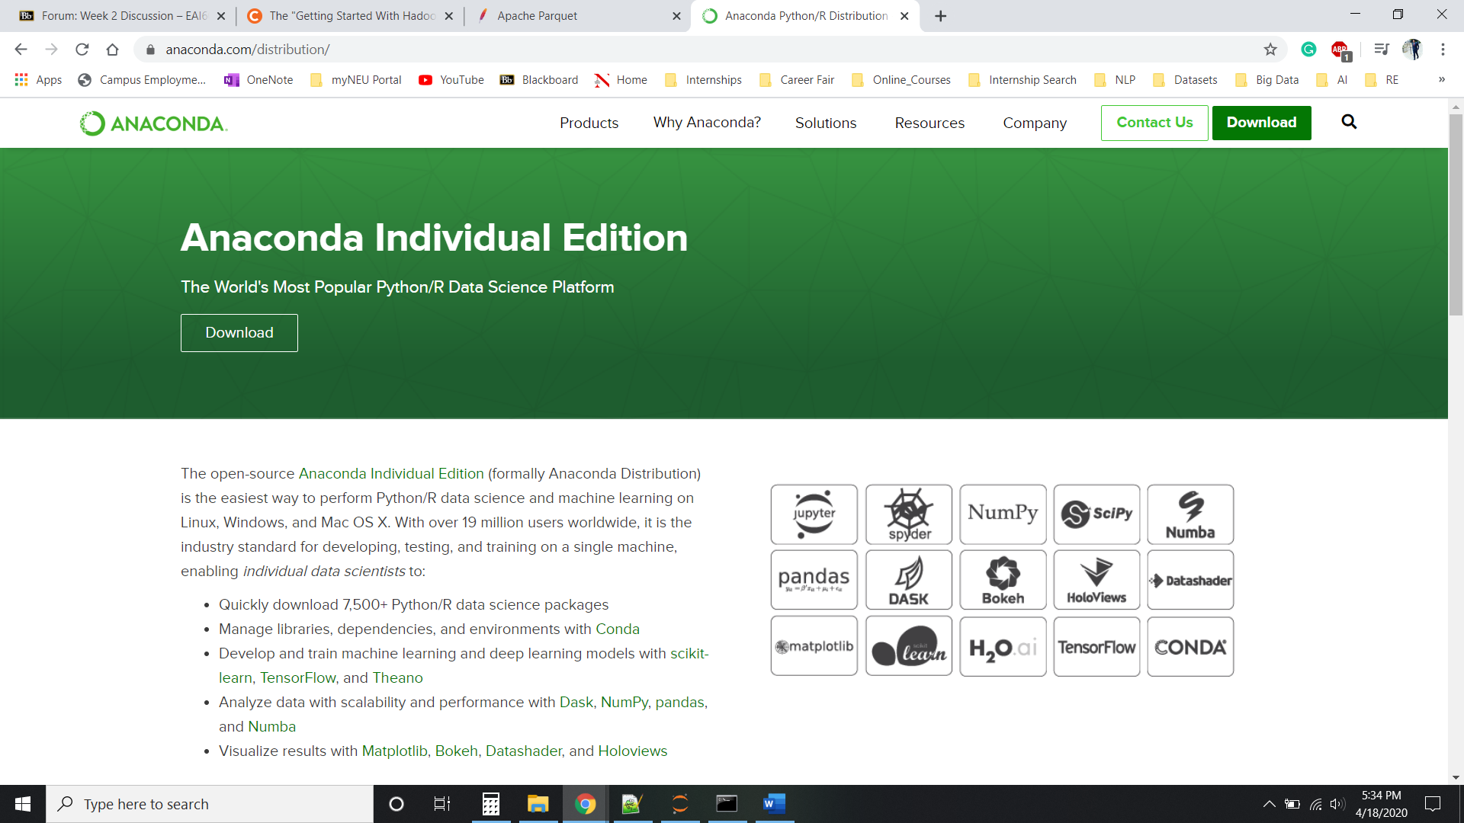

Step 3: Install Anaconda for your Operating System (Windows/ MacOS/ Linux)

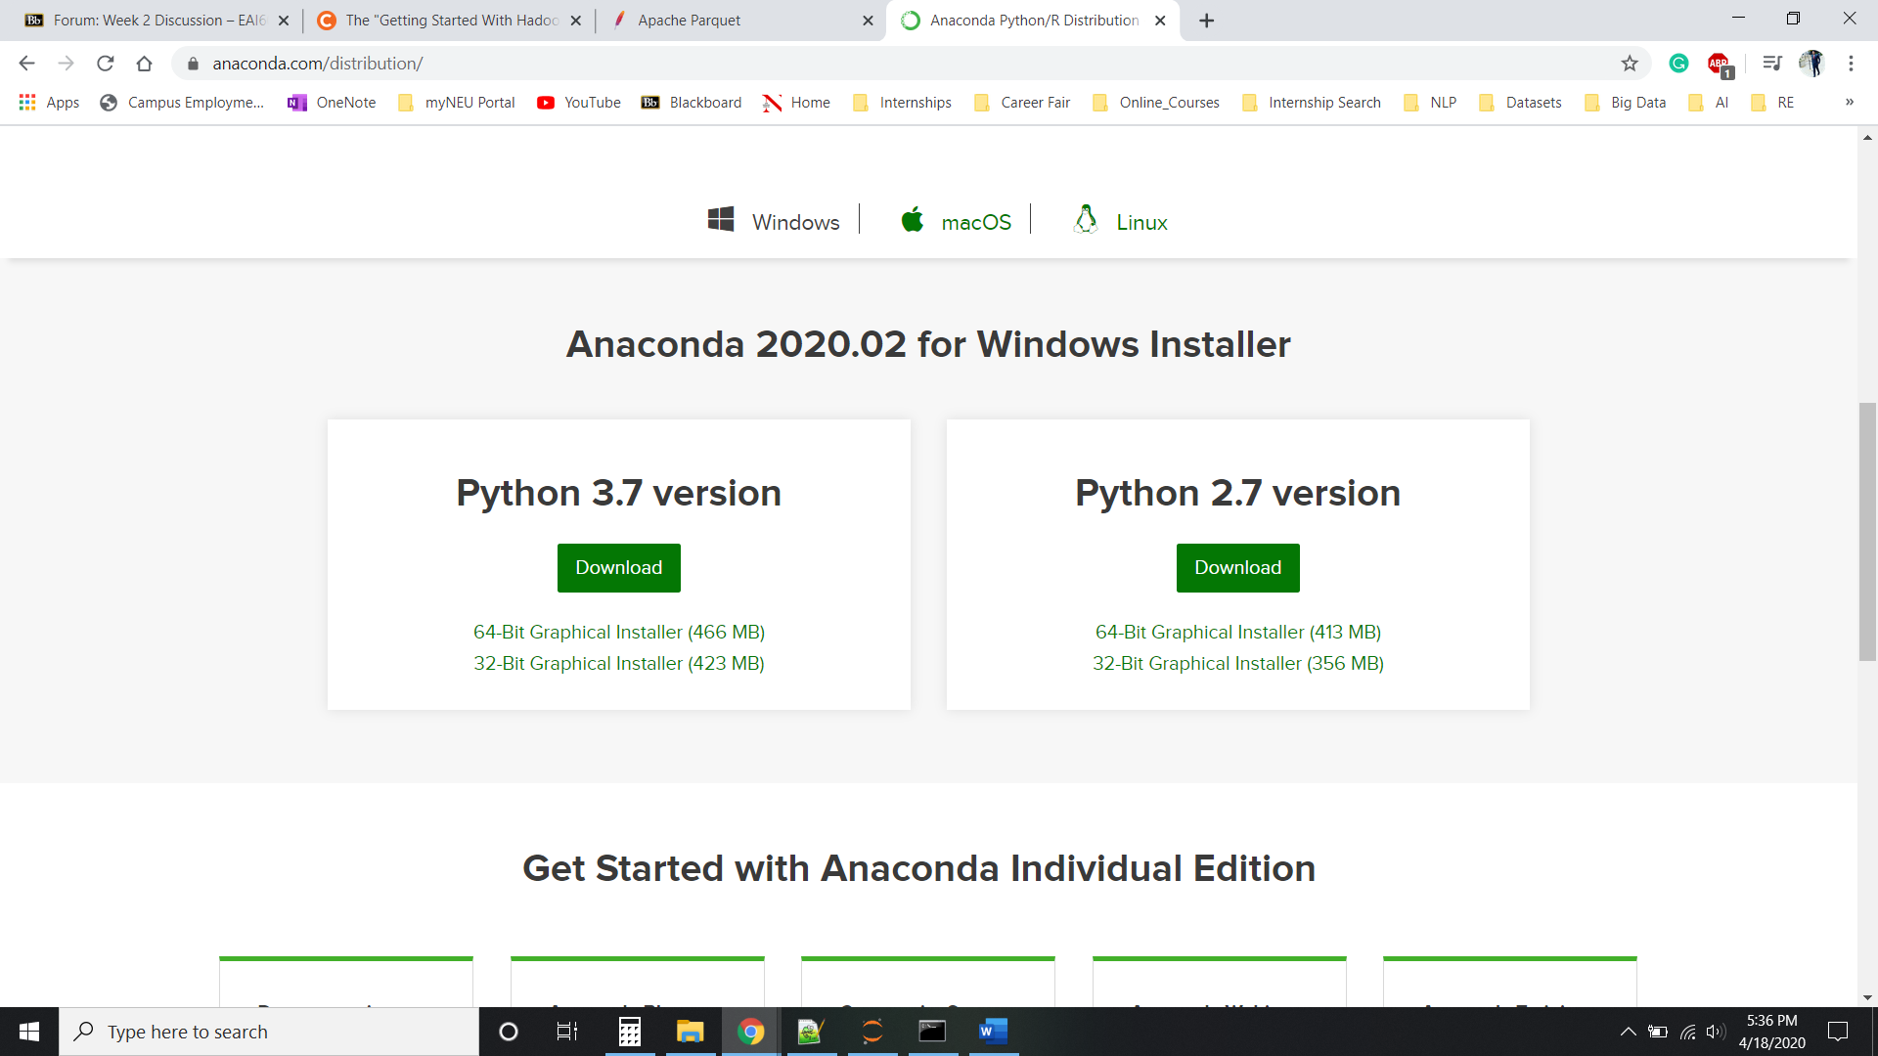

By clicking on Download in above screenshot, executable will start downloading.

Step 4: Run the executable file

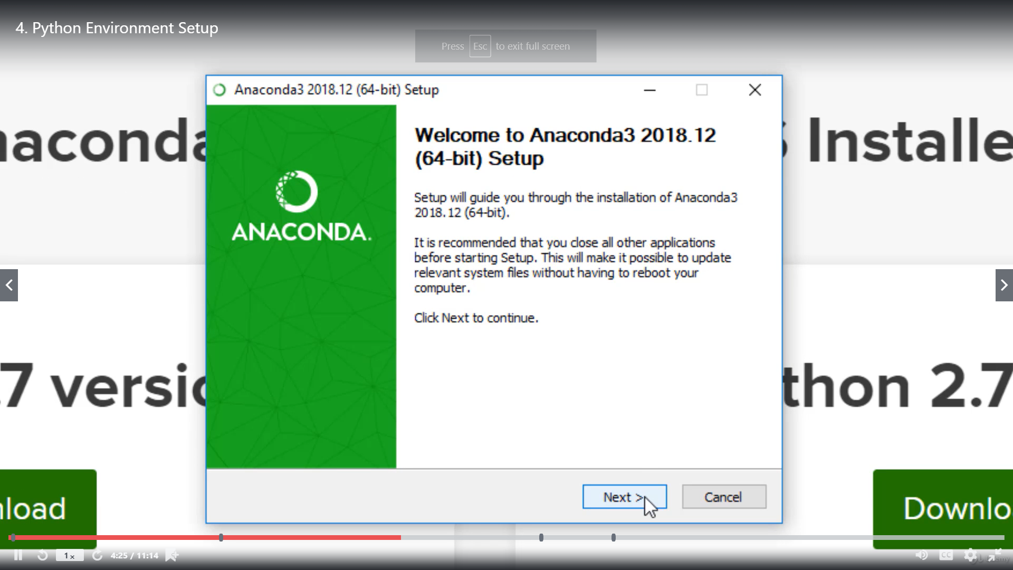

After opening executable file, click on the next to follow further, as above.

Step 5: Agree the license agreement

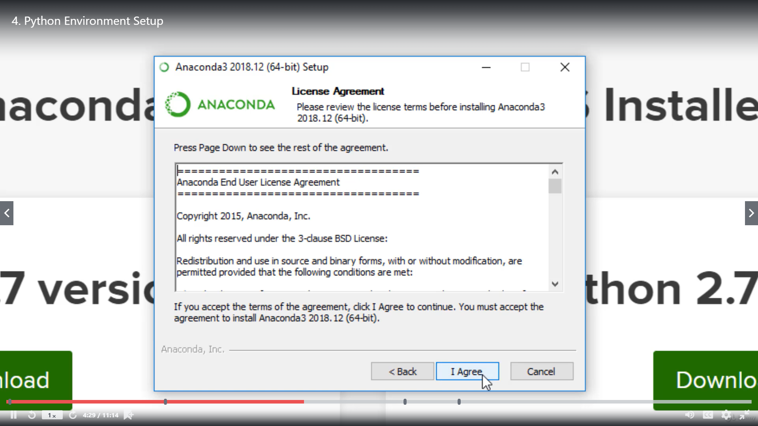

Click on the “I Agree” to accept the license agreement.

Step 6: Making visible to only 1 user

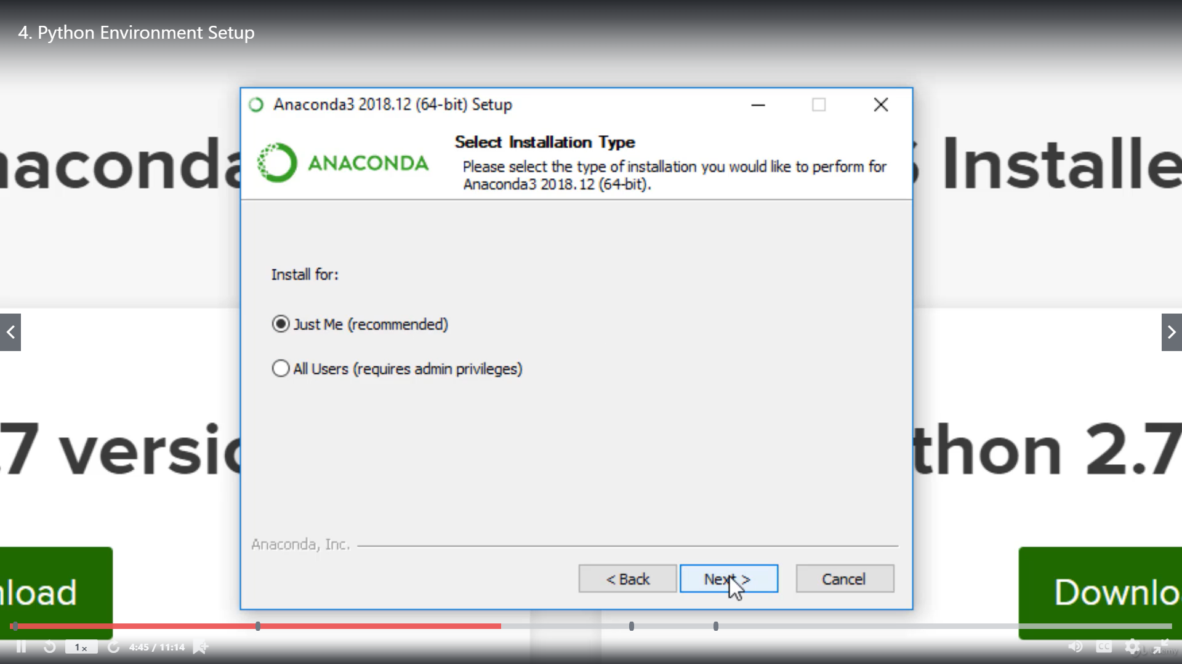

Click on “Next” by selecting “Just Me”, if you want to access by the current user.

Step 7: Installing Anaconda

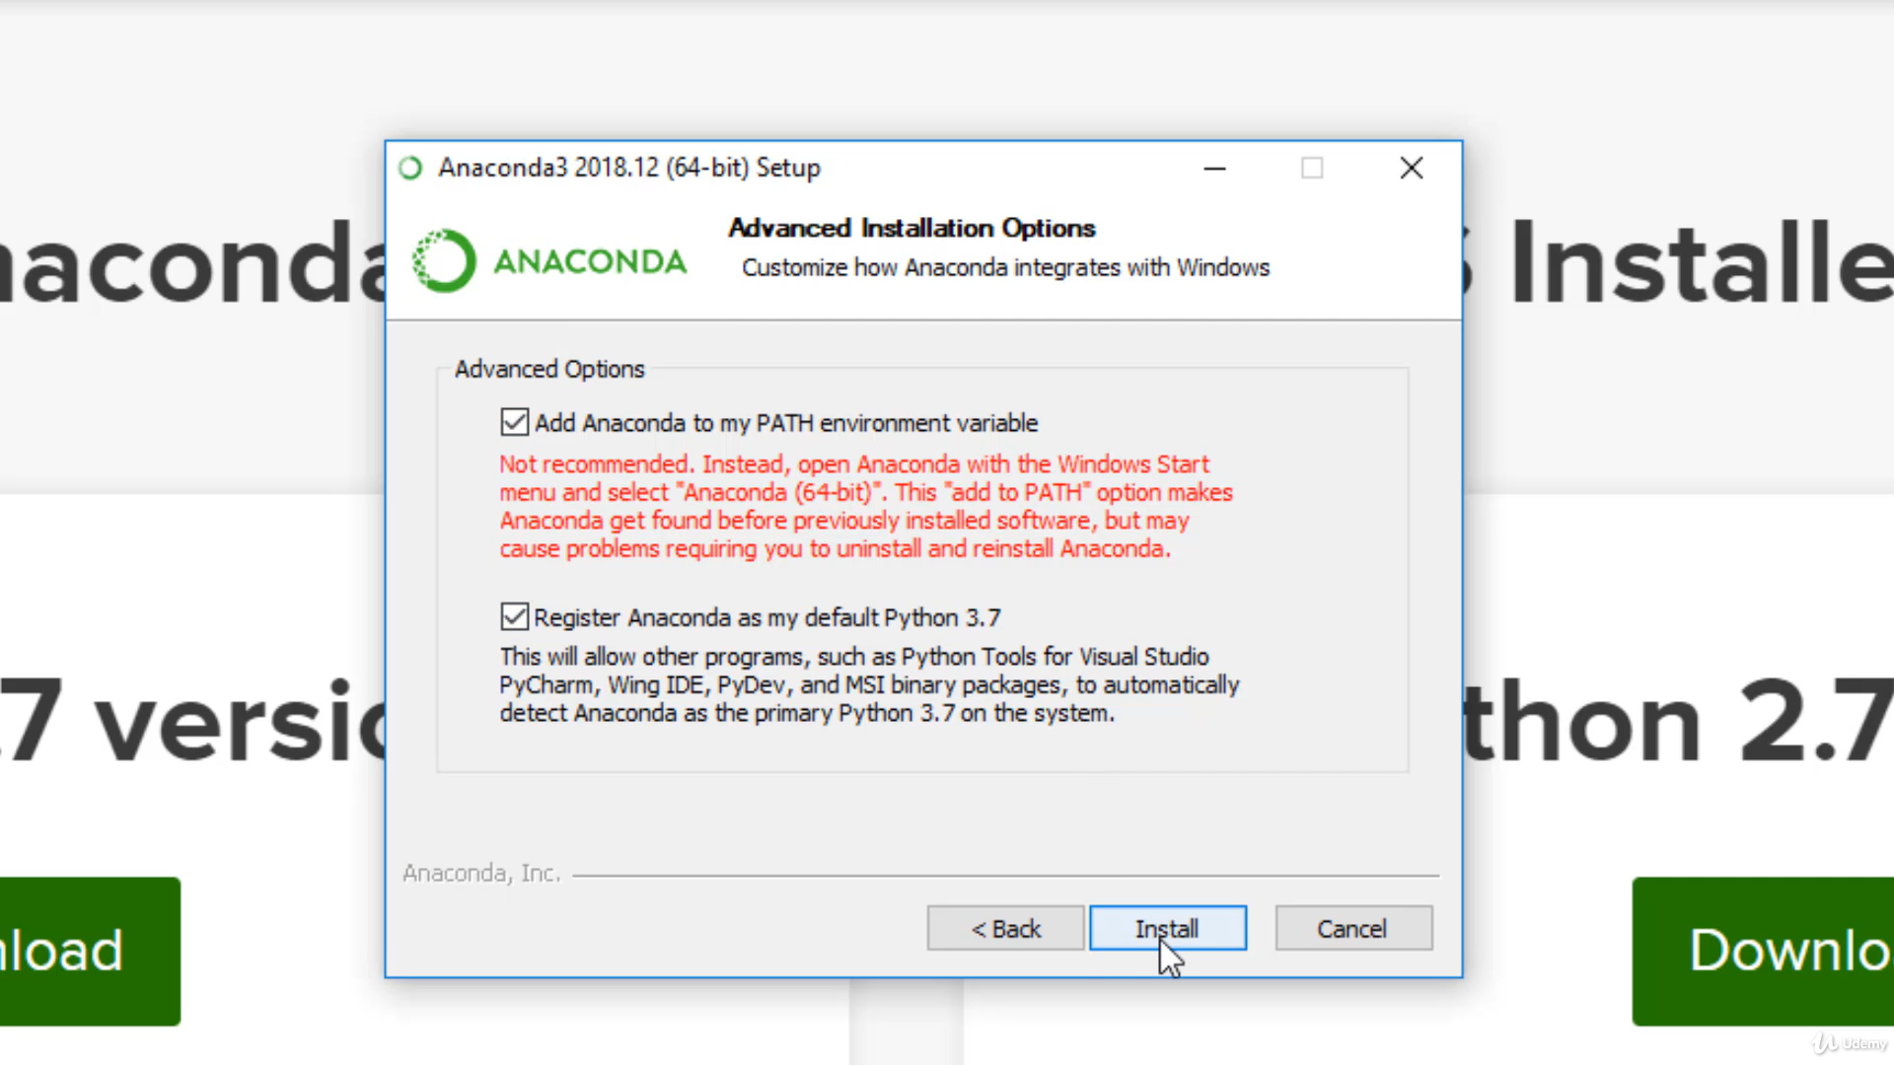

Click on “Install” to install Anaconda on your computer. Note that select an option of “Add Anaconda to my PATH Environment variable” to by default add path for environment. Then, installation will be started and wait for the completion.

Step 8: Download scripts and excel sheet

After Downloading or ensuring the latest version of python, download the Server.py and Client.py scripts along with Excel sheet of WHO_FAQ and Sentiment_recommendations.

Step 9: Open command prompt

To utilize the features of chatbot, open the command prompt (in Windows OS) or terminal (in MAC OS) as follows:

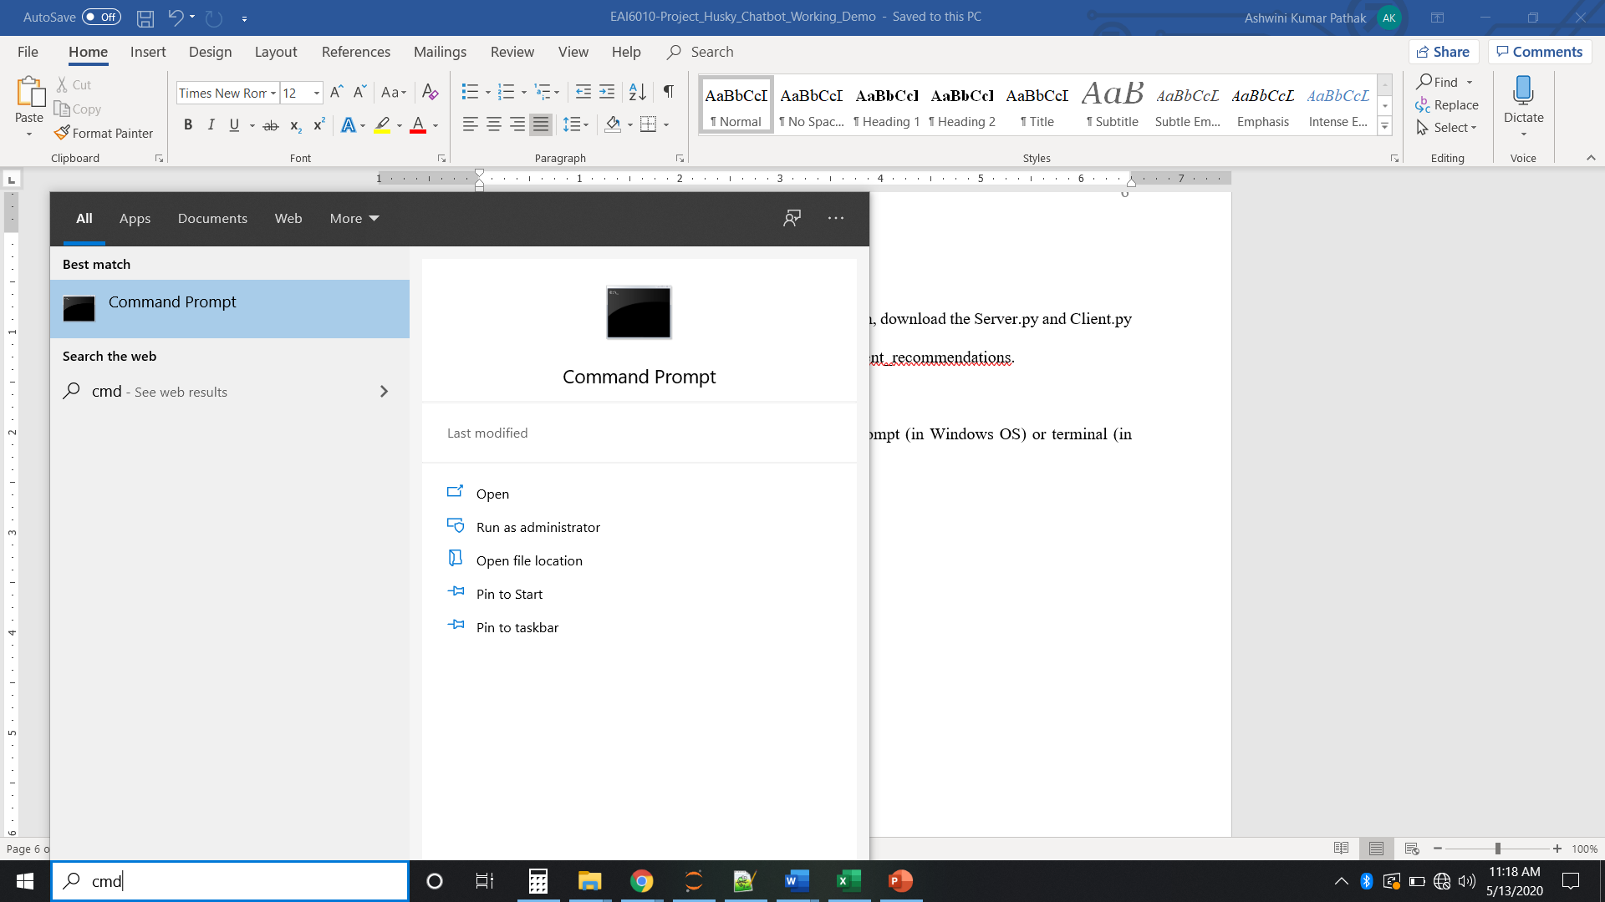

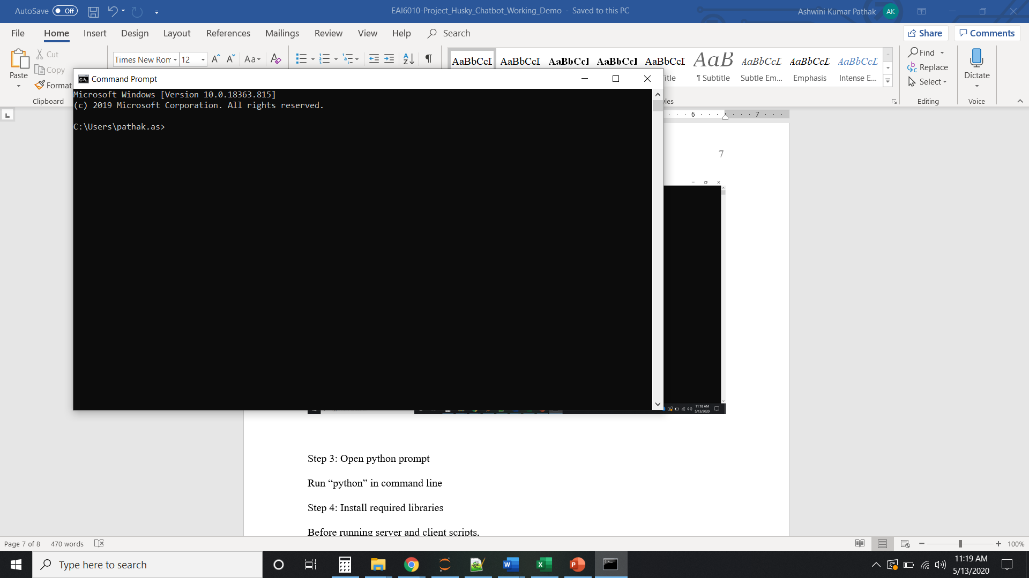

Step 10: Install required libraries

Before running server and client scripts, make sure to check following libraries in your machine using following import in command prompt after typing “python” in the command line and press enter:

import socket

import select

import sys

import threading

from _thread import *

import numpy as np

import pandas as pd

import tensorflow as tf

import tensorflow_hub as hub

import tensorflow_text

import re

import os

import random

import string

import numpy as np

import pandas as pd

from sklearn.feature_extraction.text import TfidfVectorizer

from sklearn.metrics.pairwise import cosine_similarity

import nltk

If any of the above libraries are not installed, use following command to install the libraries in command line prompt without typing “python”:

pip install <library_name>

Step 5: Go to location of server

Using the same command prompt window, go to location using following command:

cd <path_name>

Ex: cd C:\Users\pathak.as\Projects\Chatbot

Now, you will reach the path of Server.py file from command prompt.

Step 6: Run Server.py

To run the server.py file on command prompt, run the below command:

python Server.py

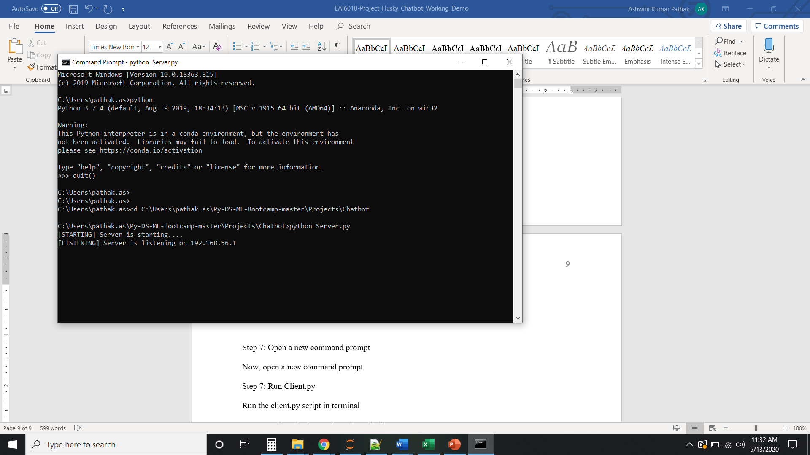

As you can see above that server is starting and it is able to listen from multiple clients.

Step 7: Open a new command prompt

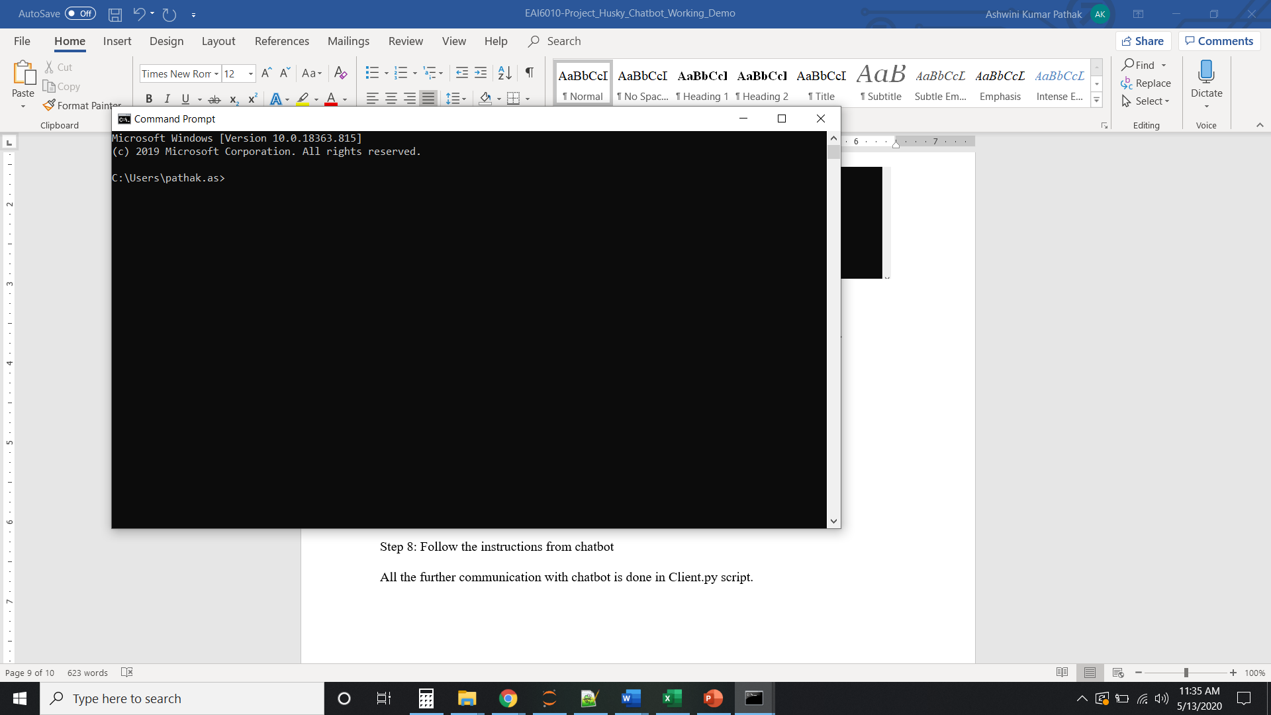

To run the client.py file, open a new command prompt as above.

Step 7: Run Client.py

Now, run the client.py script in command line as below after going to the path of Client.py file as you did for Server.py file in step 5:

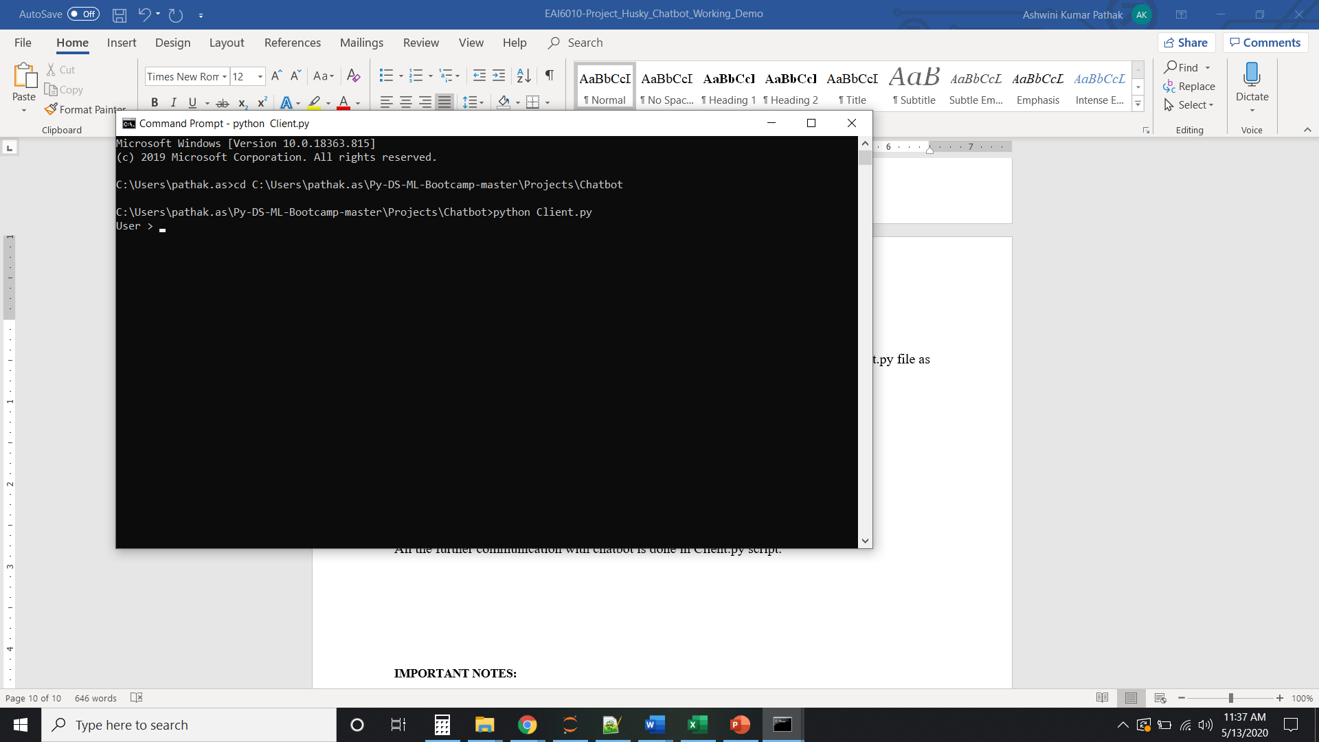

Step 8: Talk to the chatbot for information about COVID-19

Note that all the further communication with chatbot is done on command prompt window in which you run Client.py file. Say “Hi” to the chatbot and follow the steps to know more about features of chatbot. One example of same has been included as below:

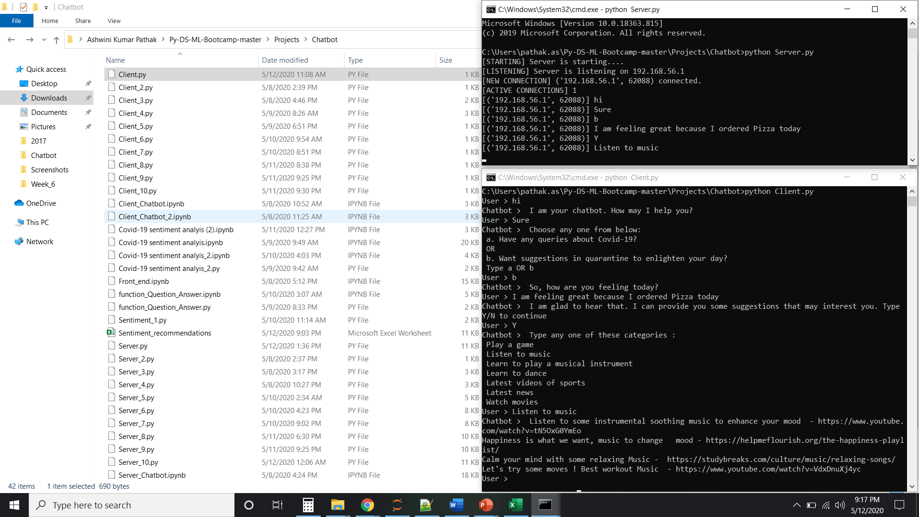

Here, chatbot is providing recommendations to user based on sentiments analysis analyzed using VADER sentiment analysis. It’s highly personalized chatbot is providing various options to choose from like Play a game, listen to music, learn to dance, and many more to help citizens to enhance their mood in this quarantine life due to COVID-19.